Email Short codes :

1. Order Status Change   
   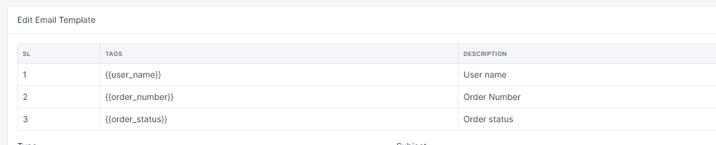
2. Account Deactivation  
   A picture containing application

   Description automatically generated
3. Password Reset  
   Graphical user interface, application

   Description automatically generated
4. Admin plan Change   
   Graphical user interface, application

   Description automatically generated
5. Contact query mail to card owner   
   Graphical user interface, application

   Description automatically generated
6. Welcome Mail  
   A picture containing graphical user interface

   Description automatically generated
7. Plan Purchase  
   Table

   Description automatically generated
8. Plan Upgrade  
   Graphical user interface, text, application

   Description automatically generated
9. Greetings to Visitor  
   Graphical user interface

   Description automatically generated
10. Request Features to Subscriber Mail  
    Table

    Description automatically generated with medium confidence
11. Product Purchase  
    Graphical user interface, table

    Description automatically generated